- Open SAM

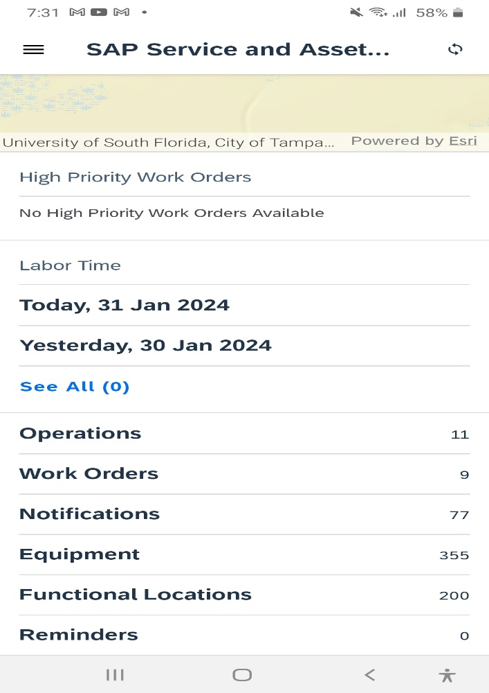

- Go to Functional Locations

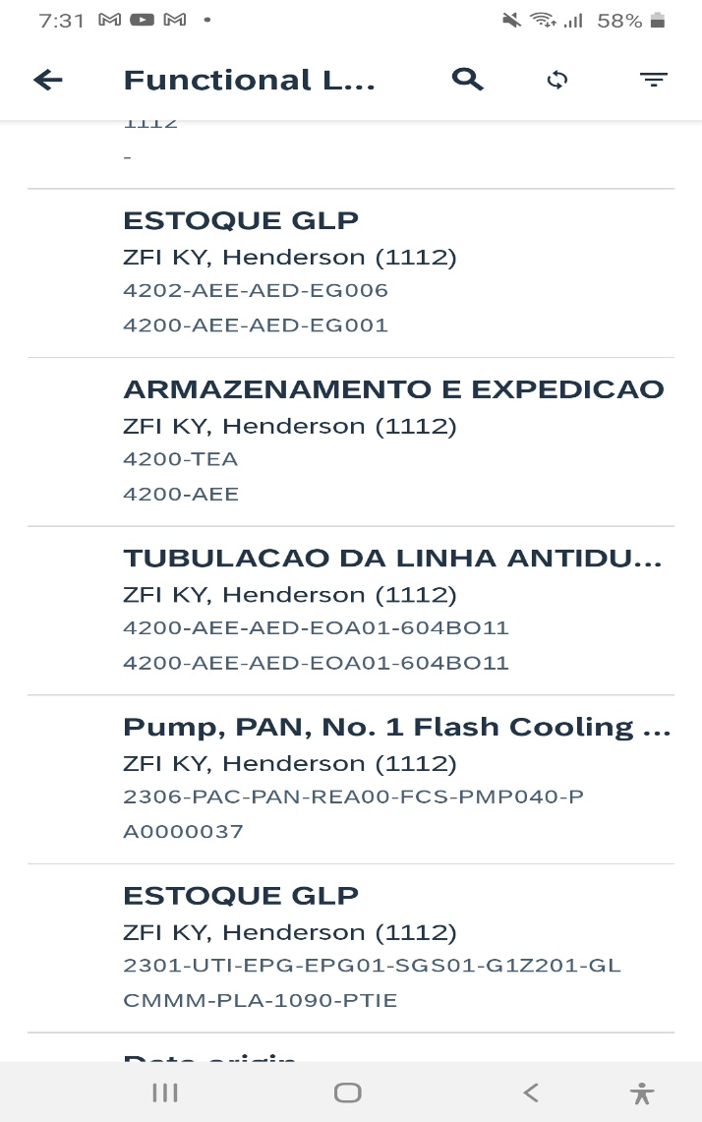

- Search with Sort Field “A0000038”.

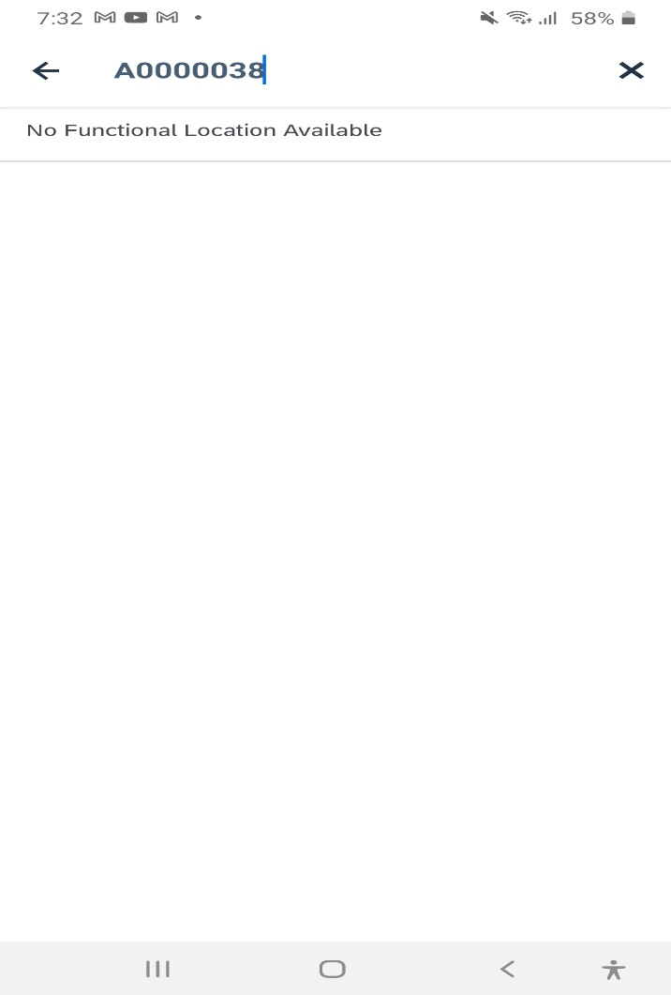

- You will not find functional location with sort Field “A0000038”
TEST RESULTS: PASS

